- Copyright for test papers and marking guides remains with West Australian Test Papers.
- The papers may only be reproduced within the purchasing school according to the advertised conditions of sale.
- Test papers must be withdrawn after use and stored securely in the school until Friday 30th November 2018.



CHEMISTRY
UNITS 1 & 2
2018

MARKING GUIDE

Section One: Multiple-choice (50 marks)

1 | a ■ b □ c □ d □ |  | 11 | a □ b □ c ■ d □ |  | 21 | a □ b ■ c □ d □
2 | a □ b □ c □ d ■ |  | 12 | a □ b ■ c □ d □ |  | 22 | a □ b □ c □ d ■
3 | a □ b □ c □ d ■ |  | 13 | a □ b □ c □ d ■ |  | 23 | a □ b ■ c □ d □
4 | a ■ b □ c □ d □ |  | 14 | a □ b ■ c □ d □ |  | 24 | a □ b ■ c □ d □
5 | a ■ b □ c □ d □ |  | 15 | a □ b □ c □ d ■ |  | 25 | a □ b □ c □ d ■

6 | a □ b □ c ■ d □ |  | 16 | a ■ b □ c □ d □
7 | a ■ b □ c □ d □ |  | 17 | a □ b □ c ■ d □
8 | a □ b □ c □ d ■ |  | 18 | a □ b □ c ■ d □ |  |  | (2 marks per question)
9 | a □ b □ c ■ d □ |  | 19 | a ■ b □ c □ d □
10 | a ■ b □ c □ d □ |  | 20 | a □ b □ c □ d ■

Section Two: Short answer 35% (70 marks)

This section has 8 questions. Answer all questions. Write your answers in the spaces provided.

When calculating numerical answers, show your working or reasoning clearly. Express numerical answers to the appropriate number of significant figures and include appropriate units where applicable.

Spare pages are included at the end of this booklet. They can be used for planning your responses and/or as additional space if required to continue an answer.
- Planning: If you use the spare pages for planning, indicate this clearly at the top of the page.
- Continuing an answer: If you need to use the space to continue an answer, indicate in the original answer space where the answer is continued, i.e. give the page number. Fill in the number of the question(s) that you are continuing to answer at the top of the page.

Suggested working time: 60 minutes.

Question 26 (6 marks)

(a) Complete the following table by either giving the correct IUPAC name of the substance or drawing a structural diagram for the organic molecule named. (3 marks)

Structural diagram | IUPAC name
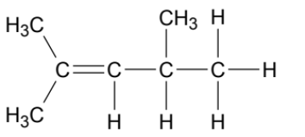 | 2,4-dimethylpent-2-ene
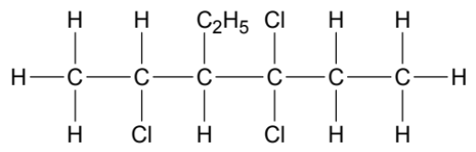 | 2,4,4-trichloro-3-ethylhexane
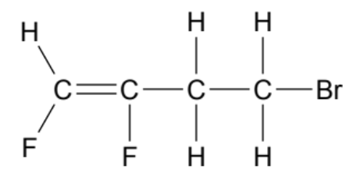 | 4-bromo-1,2-difluorobut-1-ene  * add cis-trans to name if you want to examine this

(b) Write the equation for the reaction that would take place between methylbenzene and liquid bromine in the presence of an aluminium bromide catalyst. (3 marks)

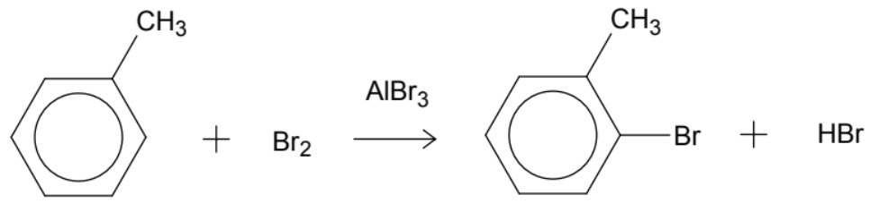
(1) reactants, (1) products, (1) catalyst
Question 27 (8 marks)

Fireflies ‘glow’ due to a special chemical reaction that produces light. Fireflies have a substance in their bodies called ‘luciferin’. The compound luciferin is oxidised to oxyluciferin by the enzyme luciferase. ATP is an organic compound that provides energy for the reaction to take place. The word equation for the ‘glow’ reaction in fireflies is shown below.

luciferase
luciferin + ATP + oxygen gas oxyluciferin + AMP + light

(a) Sketch an energy profile diagram for this reaction, in the absence of the luciferase enzyme. Label the change in enthalpy and the activation energy. (3 marks)

Progress of reaction
Potential energy (kJ)
Ea

R
ΔH
reactants

products
(1) shape
(1) Ea
(1) ΔH

(b) Add to the energy profile diagram above, the effect of the luciferase enzyme on this reaction. (1 mark)

- see dashed line on EPD above

(c) Define an ‘enzyme’ and explain, in terms of the collision theory, how enzymes increase the rate of a reaction. (3 marks)

- an enzyme is a protein known as a biological catalyst
- enzymes/catalysts provide an alternate reaction pathway with a lower activation energy
- this allows a greater proportion of particles to overcome the activation energy barrier / this results in a greater number of particles having collision energy greater than activation energy

(d) State the role of ATP in this reaction, in terms of the collision theory. (1 mark)

- provides the activation energy required / provides the energy required to break the bonds within the reactants

Question 28 (11 marks)

(a) The concentration of barium ions (Ba²⁺) in seawater is 0.025 ppm. If you had a 250 mL sample of seawater, how many barium ions would be present? Assume the density of seawater is 1.00 kg L⁻¹. (4 marks)

0.025 ppm = 0.025 mg Ba²⁺ in 1 kg seawater
i.e. 0.025 mg / 1000 = 2.5 x 10⁻⁵ g Ba²⁺ per litre seawater
therefore in 250 mL;
2.5 x 10⁻⁵ / 4 = 6.25 x 10⁻⁶ g Ba²⁺ present (2)

OR m(Ba²⁺ in 250 mL) = 0.025 x 0.25 = 0.00625 mg
therefore 0.00625 / 1000 = 6.25 x 10⁻⁶ g Ba²⁺ present (2)

n(Ba²⁺ in 250 mL) = m/M = 6.25 x 10⁻⁶ / 137.3
= 4.5521 x 10⁻⁸ mol (1)

N(Ba²⁺) = n x Av
= 4.5521 x 10⁻⁸ x 6.022 x 10²³ (1)
= 2.74126 x 10¹⁶ ions present = 2.7 x 10¹⁶ ions (2 SF)

(b) Draw a labelled diagram showing how dissolved Ba²⁺ and Cl⁻ ions would interact with the water molecules in the ocean. (3 marks)

- barium ion and
Ba²⁺
Cl⁻
water molecules
ion-dipole forces
surrounding water

- chloride ion and
surrounding water

- labelled ion-dipole
forces

The solubility of barium chloride (BaCl₂) is 35.8 g per 100 mL water at 20 °C.

(c) How would you produce a saturated solution of barium chloride if you had 250 mL of water at 20 °C? (2 marks)

- weigh out 89.5 g of BaCl₂ (35.8 x 2.5 = 89.5 g)
- dissolve it into the 250 mL of water

The sea surface temperature at Cottesloe beach in summer can reach 23 °C.

(d) If your saturated solution from (c) was heated to 23 °C, would the solution now likely be saturated, unsaturated or supersaturated? Justify your answer. (2 marks)

- unsaturated
- an increased temperature (usually) increases the amount of solid solute that will dissolve in a solvent (therefore the solution is now holding less than maximum amount of solute)

Question 29 (8 marks)

Consider the information in the table, regarding the conductivity of substances W, X, Y and Z.

Substance | Conductivity (l) | Conductivity (aq)
W | no | yes
X | yes | yes
Y | no | no (not soluble in water)
Z | yes | no (not soluble in water)

(a) Which of these substances is most likely to be malleable? Justify your answer in terms of the structure and bonding present. (4 marks)

- Z
- Conducts as a liquid (therefore metal or ionic) but not as aqueous (unlike X) so most likely to be metal
Metals have a delocalised sea of electrons (also accept labelled accurate diagram of metallic bonding)
- Therefore when a force is applied they can distort without disrupting the bonding

(b) Name or give the formula for one possible identity of substance W. (1 mark)

- any covalent molecular acid or base (e.g. CH₃COOH, HCl, NH₃…)

(c) Which of these substances is most likely to be diamond? Briefly describe the structure and bonding within diamond. (3 marks)

- Y
- Diamond is made of carbon atoms, where every carbon is bonded to 4 other carbons (also accept labelled accurate diagram of diamond)
- This forms a strong interconnected 3D network of covalent bonding

Question 30 (10 marks)

Some chemistry students were investigating the pH of various compounds. In particular, they were investigating sodium hydroxide (NaOH) and ammonia (NH₃). The students knew that both of these compounds were classified as bases because they produce hydroxide ions (OH⁻) in solution.

They were given a sample of 0.5 mol L⁻¹ NaOH(aq) and 0.5 mol L⁻¹ NH₃(aq). The students added a few drops of universal indicator to each solution.

(a) What is an indicator? (1 mark)

- a substance that changes colour depending on the pH

(b) Explain why the NaOH(aq) would have a higher pH than the NH₃(aq). (4 marks)

- NaOH is a strong base whereas NH₃ is a weak base
- NaOH completely dissociates in solution, producing OH⁻ ions (also accept equation NaOH → Na⁺ + OH⁻)
- NH₃ only partially ionises in solution to produce a small amount of OH⁻ ions (also accept equation NH₃ + H₂O  NH₄⁺ + OH⁻)
- A higher concentration of OH⁻ corresponds to a higher pH / more basic solution

The students’ teacher was explaining that the pH scale is a measure of the concentration of hydrogen ions (H⁺) in a solution. One of the students asked, “According to the Arrhenius theory, if bases are substances that produce hydroxide ions in solution, how can their pH be measured?”

(c) Briefly answer the student’s question. (3 marks)

- all aqueous solutions have a some H⁺ present
- bases contain very low concentrations of H⁺
- a low H⁺ concentration corresponds to a high pH (also accept explanations involving the formula pH = -log [H⁺])

The students then investigated a chemical reaction involving both sodium hydroxide and ammonia. They noted the following observations in their laboratory book;

“A clear colourless solution with a highly basic pH was added to a white powder. A pungent smelling odour was detected and the white powder dissolved forming a clear, colourless solution. This solution was later determined to be aqueous sodium chloride.”

(d) Write the balanced chemical equation for this reaction. (2 marks)

NaOH(aq) + NH₄Cl(s) → NH₃(g) + NaCl(aq) + H₂O(l)

OR

OH⁻(aq) + NH₄Cl(s) → NH₃(g) + Cl⁻(aq) + H₂O(l)

(1) reactants, (1) products
Question 31 (9 marks)

Consider the graph below, which shows the first six (6) ionisation energies of magnesium and phosphorus.

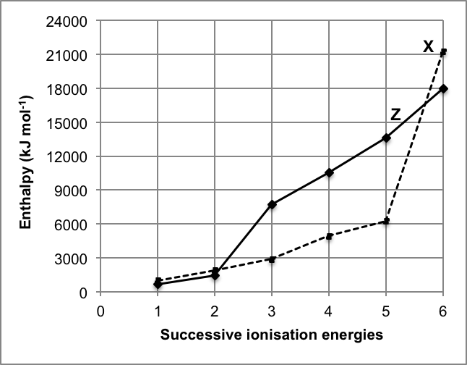

(a) Complete the table below, by writing the electron configuration for magnesium and phosphorus, as well as identifying which line on the graph (X or Z) corresponds to each element. (3 marks)

 | Electron configuration | Line X or Z?
Magnesium | 2, 8, 2 (1) | Z  (1)
Phosphorus | 2, 8, 5 (1) | X

(b) Why is the first ionisation energy of X higher than that of Z? (3 marks)

- P / X has a smaller atomic radius / valence shell closer to the nucleus, and
- an increased positive nuclear charge / effective nuclear charge than Mg / Z
- this leads to an increased force of attraction and therefore more energy is required to remove the valence electron

(c) Describe how X and Z could combine by forming chemical bonds. Give the formula of the most likely compound that would form. (3 marks)

- ionic bonds could form
- Mg would donate electrons, P would accept electrons, in order to achieve a stable octet
- Mg₃P₂ / Z₃X₂

Question 32 (8 marks)

Azurite, Cu₃(CO₃)₂(OH)₂, is a common copper-containing compound found in some copper ores.

(a) Calculate the percentage by mass of copper in azurite, Cu₃(CO₃)₂(OH)₂. (2 marks)

% Cu = ( 3 x 63.55 ) / 344.686 x 100
= 55.31 %

Some copper ore, containing 61.5% azurite, was smelted to extract the copper according to the equation below.

2 Cu₃(CO₃)₂(OH)₂(s) + 3 C(s) → 6 Cu(s) + 7 CO₂(g) + 2 H₂O(g)

If 2.98 tonnes of copper was produced;

(b) Calculate the volume of carbon dioxide (at STP) that would have been released. (3 marks)
* alter P and T conditions to examine PV=nRT

m(Cu) = 2.98 x 10⁶ g

n(Cu) = m/M
= 2.98 x 10⁶ / 63.55
= 46 892.211 mol

n(CO₂) = n(Cu) / 6 x 7
= 54 707.579 mol

V(CO₂) = 22.71n
= 22.71 x 54 707.579
= 1 242 409.127 L
= 1.24 x 10⁶ L OR 1240 kL OR 1.24 ML (3 SF)

(c) Calculate the mass of azurite, Cu₃(CO₃)₂(OH)₂, that was smelted. (2 marks)

n(Cu₃(CO₃)₂(OH)₂) = n(Cu) / 6 x 2
= 15 630.737 mol

m(Cu₃(CO₃)₂(OH)₂) = nM
= 15 630.737 x 344.686
= 5 387 696.214 g
= 5.39 x 10⁶ g OR 5390 kg OR 5.39 t (3 SF)

(d) Calculate the mass of ore that would have been required as the starting material. (1 mark)

m(ore) = m(Cu₃(CO₃)₂(OH)₂) x 100/61.5
= 8 760 481.648 g
= 8.76 x 10⁶ g OR 8760 kg OR 8.76 t (3 SF)
Question 33 (10 marks)

The diagram below shows some of the gases that enter and exit a catalytic converter.

CH₄ catalytic CO₂
NO_{x} converter N₂
CO H₂O

(a) What is the function of a catalytic converter? (1 mark)

- reduce pollutants like unburnt petrol, carbon monoxide and nitrous oxides emitted by car engines / converts poisonous substances like carbon monoxide and nitrous oxides into more harmless substances like carbon dioxide and nitrogen

(b) Choose three (3) of the gases labelled in the diagram above and complete the following table by;
- drawing the structural formula for each molecule, representing all valence shell electron pairs either as : or –,
- naming the shape of the molecule, and
- stating the most significant intermolecular forces present in a pure sample.

Each of your chosen gases must have a different molecular shape. (9 marks)

Electron dot diagram | Shape | Intermolecular forces
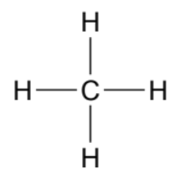 | tetrahedral | dispersion
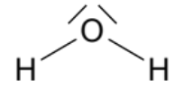 | v-shaped / bent | hydrogen bonds
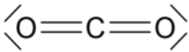  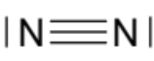  . C . O  xx  x x  x x  . . | linear | dispersion  dispersion  dipole-dipole

End of Section Two
Section Three: Extended answer 40% (80 marks)

This section contains five (5) questions. You must answer all questions. Write your answers in the spaces provided below.

Where questions require an explanation and/or description, marks are awarded for the relevant chemical content and also for coherence and clarity of expression. Lists or dot points are unlikely to gain full marks.

Final answers to calculations should be expressed to the appropriate number of significant figures.

Spare pages are included at the end of this booklet. They can be used for planning your responses and/or as additional space if required to continue an answer.
- Planning: If you use the spare pages for planning, indicate this clearly at the top of the page.
- Continuing an answer: If you need to use the space to continue an answer, indicate in the original answer space where the answer is continued, i.e. give the page number. Fill in the number of the question(s) that you are continuing to answer at the top of the page.

Suggested working time: 70 minutes.

Question 34 (14 marks)

Several different brands of sports drinks were analysed by atomic absorption spectroscopy (AAS) to determine their sodium content. Sports drinks contain sodium in the form of sodium ions, Na⁺. A diagram of the equipment used in AAS is shown below.

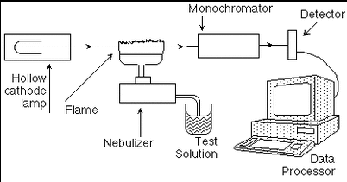

In this analysis, the element in the hollow cathode lamp contained sodium (Na). When the lamp is turned on, the atoms of sodium produce an emission spectrum that is unique to the sodium element.

(a) Explain how sodium atoms are able to produce this unique emission spectrum. (3 marks)

- when electrons absorb energy they are able to move up to a higher energy level (the electrons moves from the ground state to ‘excited’)
- as the electrons move back down to their original level they release the energy again
- this energy produces the emission spectrum which is made up of a particular set of frequencies/wavelengths that are unique to each element

(b) Why does the emission spectrum of the hollow cathode lamp need to match the metal being analysed by AAS? (2 marks)

- the metal has the ability to absorb the exact frequency/wavelengths in the emission spectrum
- therefore the absorption will correlate / be proportional to the concentration of metal present

Samples of each sports drink were diluted with water and then run through the spectrometer. Absorbance values for each were collected. The data was then compared to an existing calibration curve for sodium, which is shown below.

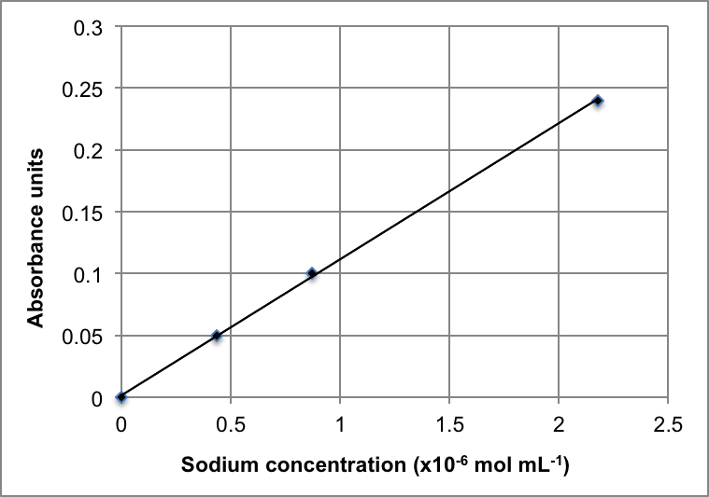

(c) Describe how this calibration curve would have been obtained. (3 marks)

- Na standards / solutions with a known Na concentration
- Would have been run through the AAS to measure their absorbance
- These absorbance values would have been plotted and then a line of best fit drawn

Using the calibration curve above, the concentration for a particular diluted sports drink was determined to be 1.11 x 10⁻⁶ mol mL⁻¹.

(d) What absorbance would this correspond to? (1 mark)

- accept 0.12 to 0.13

A 10.00 mL sample of a sports drink was taken and diluted to a final volume of 250.0 mL by the addition of water. A portion of the dilute sample was analysed by AAS.


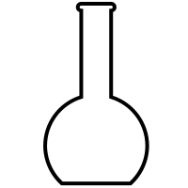
sample diluted to 250.0 mL with water
10.00 mL sample of sports drink taken
dilute sample analysed by AAS

The absorbance obtained was compared to the calibration curve and the concentration was determined to be 1.11 x 10⁻⁶ mol mL⁻¹ as previously stated.

(e) Calculate the concentration of sodium (in mol L⁻¹) in the undiluted sports drink. (3 marks)

c(Na⁺) = 1.11 x 10⁻⁶ mol mL⁻¹ = 1.11 x 10⁻⁶ x 10³ = 1.11 x 10⁻³ mol L⁻¹ (1)

c₁ = c₂V₂ / V₁
= (1.11 x 10⁻³ x 0.250 ) / 0.010
= 0.027729 mol L⁻¹
i.e. concentration of Na⁺ in sports drink is 0.0277 mol L⁻¹ (3 SF) (2)

OR

n(Na⁺ in 250 mL) = cV
= 1.11 x 10⁻³ x 0.25
= 0.000277295 mol
= n(Na⁺ in 10 mL sample) (1)

c(Na⁺ in 10 mL) = n/V
= 0.000277295 / 0.010
= 0.027729 mol L⁻¹
i.e. concentration of Na⁺ in sports drink is 0.0277 mol L⁻¹ (3 SF) (1)

The sports drink was sold in a 600 mL bottle.

(f) Calculate the total mass of sodium present in the drink. (2 marks)

n(Na⁺) = cV
= 0.027729 x 0.600
= 0.01663767 mol

m(Na⁺) = nM
= 0.01663767 x 22.99
= 0.3825 g
= 0.383 g (3 SF)
Question 35 (15 marks)

A chemistry class was investigating the topic of reaction rate. The students decided to use the reaction between solid zinc granules and hydrochloric acid, because they would be able to time how long it took for the zinc to completely dissolve. The students wanted to see how the rate of a reaction changes over time. They wrote the following hypothesis;

“The rate of reaction will decrease over time and this will be observed by a uniform (linear) decrease in the mass of zinc present in the beaker.”

The data collected by the students is represented in the graph below.

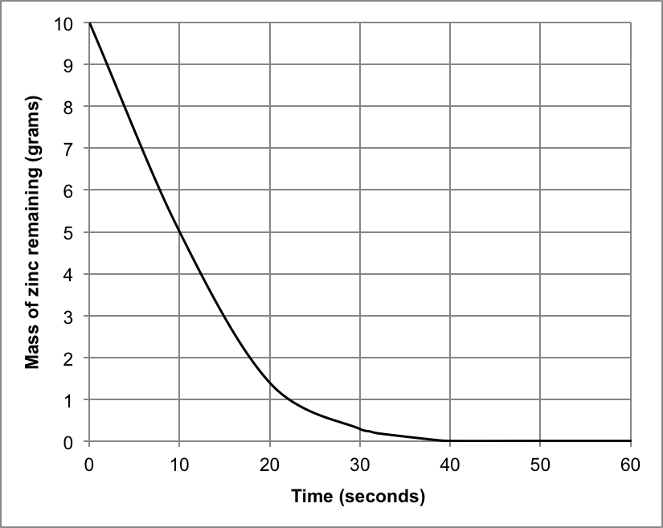

(a) Write a balanced ionic equation for the reaction that is occurring in this investigation. State the corresponding observations. (4 marks)

Ionic equation | Zn(s) + 2 H⁺(aq) → Zn²⁺(aq) + H₂(g)  (1) eq, (1) balanced
Observations | Silver metal dissolves in clear colourless solution, colourless odourless gas produced (test tube feels warm)  (1) reactants, (1) products

(b) How long did it take before; (2 marks)

- half of the zinc had reacted? 10 s

- the rate of the reaction became zero? 40 s

(c) Was the students’ hypothesis completely supported? Justify your answer by referring to the graph. (2 marks)

- no
- the mass of Zn did not decrease linearly

The students then performed three (3) variations of the investigation described above. They altered one particular aspect of the experiment each time, to determine the effect of the various factors on the rate of reaction.

The results of two (2) of the variations, labelled A and B, are shown in the graph below (dotted lines). The original data is also displayed for comparison (solid line).

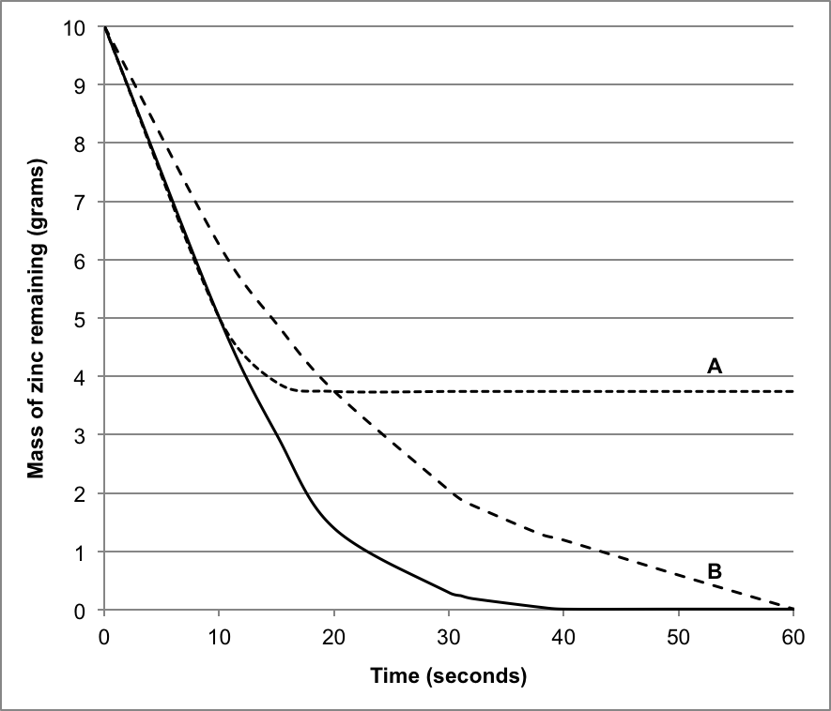
C

Consider lines A and B on the graph on page 24. In each of these experiments, only one variable was changed in comparison with the original experiment (solid line). The changes made were;

- the concentration of acid was halved
- the volume of acid was halved

(d) Complete the table below by stating which line on the graph corresponds to the changes made to the original experiment. (2 marks)

 | A or B?
The concentration of acid was halved. | B
The volume of acid was halved. | A

(e) Justify your choices in part (d) by referring to the graph. (4 marks)

with the concentration of acid halved;
- this would result in less collisions and therefore a slower reaction rate
- represented on the graph by a slower decrease in the mass of Zn and a longer time until reaction rate becomes zero (60 s)

with the volume of acid halved;
- this would not affect concentration and therefore the reaction rate would be the same at the start
- but then the acid must run out (become limiting), since the rate becomes zero at ~18 s before all the Zn is used up

The third variation of the experiment that the students investigated was increasing the temperature of the hydrochloric acid before pouring it over the zinc granules.

(f) Sketch a fourth line, labelled C, on the graph on page 24, displaying the results you would expect the students to have obtained. (1 mark)

- see line on graph above (accept any line with steeper gradient than original, and meeting x axis before 40 s)

Question 36 (17 marks)

High performance liquid chromatography (HPLC) is often used to test water for potential contamination. One particular analysis determines the levels of a range of polycyclic aromatic hydrocarbons (PAHs) in water. These pollutants are naturally occurring, but can be damaging when consumed in high levels.

The table below provides information about seven (7) different PAHs that commonly appear in water samples.

 | PAH | MF | Source of PAH
1 | naphthalene | C₁₀H₈ | coal tar, petroleum
2 | fluorene | C₁₃H₁₀ | coal tar
3 | anthracene | C₁₄H₁₀ | coal tar
4 | pyrene | C₁₆H₁₀ | crude oil, fossil fuels
5 | chrysene | C₁₈H₁₂ | coal tar
6 | benzofluoranthene | C₂₀H₁₂ | crude oil, petrol exhaust
7 | indenopyrene | C₂₂H₁₂ | coal tar, diesel exhaust

HPLC analysis can determine both the presence and concentration of these PAHs in a water sample. The chromatogram below is a control, showing each of the seven PAHs and their corresponding retention times. The absorbance readings were recorded at 254 nm.

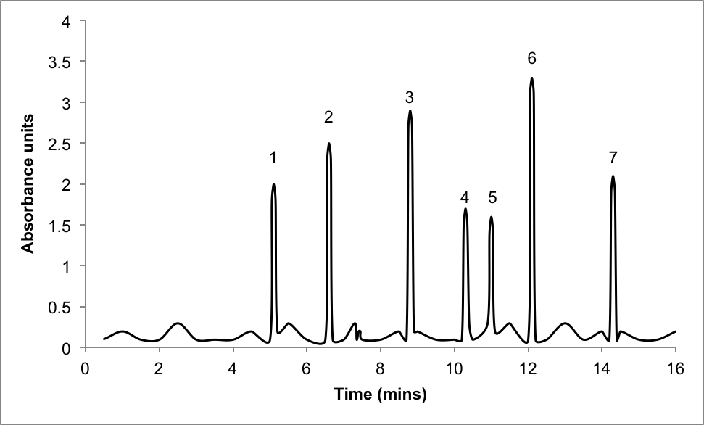

Three water samples (A, B and C) were collected from various locations and analysed for the presence of these seven PAHs. The HPLC conditions used were identical to those used in the control chromatogram. The results of the three analyses are shown in the chromatograms below.

SAMPLE A
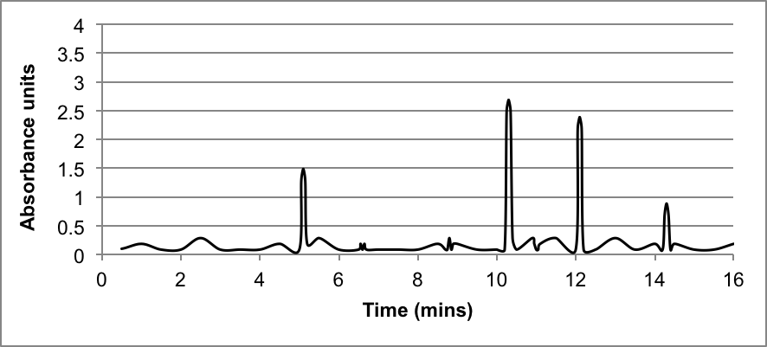

SAMPLE B
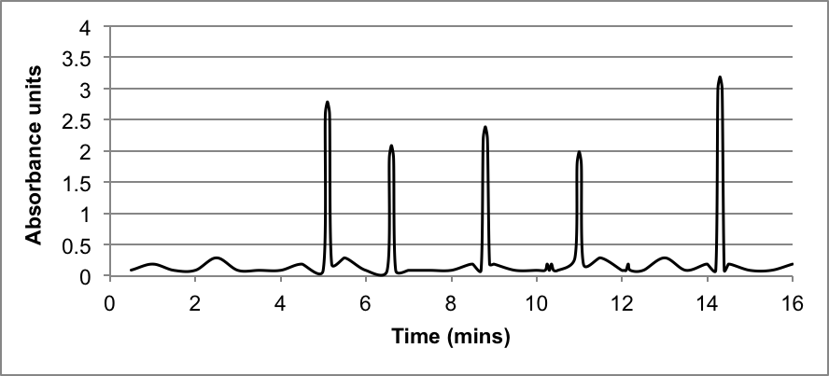

SAMPLE C
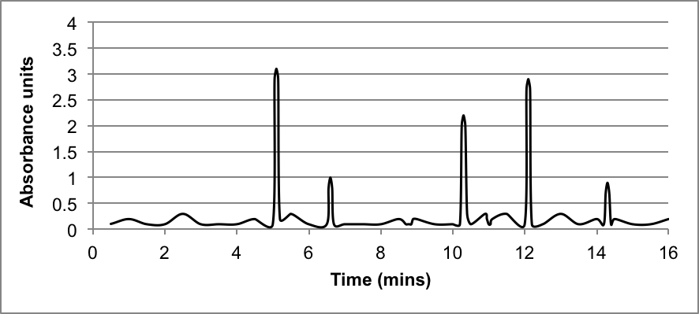

(a) State two (2) controlled variables that would need to be considered to keep the HPLC conditions identical. (2 marks)

- same stationary phase, same mobile phase, same temperature conditions, same pressure conditions… (any 2 relevant points)

(b) Name the significant contaminant(s) common to all of the water samples. (1 mark)

- naphthalene and indenopyrene

(c) Which water sample has the highest concentration of pyrene? (1 mark)

- Sample A

This particular HPLC analysis utilises a non-polar stationary phase with a mixture of water and acetonitrile as the polar mobile phase.

(d) Briefly explain the principles of HPLC and how the various components of a mixture are separated in this process. (4 marks)

- the sample / mixture to be separated is loaded into the column / onto the stationary phase and the mobile phase moves through the column
- components of the mixture adsorb onto the stationary phase with differing strengths
- components also interact with / dissolve in the mobile phase to different degrees
- the interactions between the components and the stationary and mobile phases means they move through the column at different speed and therefore become separated

(e) Since all the PAHs are non-polar substances, what characteristic has allowed them to be separated in this case? (2 marks)

- separate based on molecular weight
- low molecular weight elutes first / has shortest retention time OR high molecular weight elutes last / has longest retention time

(f) If a polar compound was identified by this HPLC analysis, what retention time would you predict it to have? Justify your answer. (2 marks)

- any retention time lower than 5 mins
- a polar compound would dissolve in / interact more with the polar mobile phase, and would therefore move through the column more quickly

(g) Which water sample is most likely to be contaminated by coal tar? Justify your answer.
(2 marks)

- Sample B
- Contains all the components listed as being found in coal tar (1, 2, 3, 5, 7)

It is important that the quality of potable water is monitored and maintained to a high standard, to ensure the water does not pose any health risks.

(h) What is ‘potable water’? Briefly describe one (1) process by which water may be purified or treated before it joins the main water supply? (3 marks)

- potable means drinking water (1)

- any relevant ‘treatment’ (1) plus brief description of purpose (1)

i.e. desalination - to remove salt
chlorination - to oxidise contaminants
disinfectant - kill bacteria / viruses
fluoridation - health benefits / lower tooth decay
filtration - remove solid particles

Question 37 (17 marks)

Propane (C₃H₈) can be obtained from the processing of natural gas or petroleum refining. It is a gas at room temperature, but can be liquefied by pressure, which makes it easy to transport and store. For this reason, propane is a commonly used fuel in barbeques, portable stoves and heating devices.

The combustion equation for propane is;

C₃H₈(g) + 5 O₂(g) → 3 CO₂(g) + 4 H₂O(g) + 2220 kJ

If 455 kg of propane was combusted in air, calculate;

(a) the volume of gaseous products that would form at STP. (5 marks)
* alter P and T conditions to examine PV=nRT

m(C₃H₈) = 455 x 10³ g (1)

n(C₃H₈) = m/M
= 455 x 10³ / 44.094
= 10 318.864 mol (1)

n(gas products) = n(C₃H₈) x 7
= 10 318.864 x 7
= 72 232.05 mol (2)

V(gas products) = 22.71n
= 22.71 x 72 232.05
= 1 640 389.849 L
= 1.64 x 10⁶ L OR 1640 kL OR 1.64 ML (3 SF) (1)

* If students have calculated gases separately;
n(CO₂) = 30 956.592 mol, V(CO₂) = 703 024 L
n(H₂O) = 41 275.456 mol, V(H₂O) = 937 366 L

(b) the energy released. (1 mark)

energy released = n(C₃H₈) x 2220 kJ
= 10 318.864 x 2220
= 22 907 878 kJ
= 2.29 x 10⁷ kJ

Biopropane is a biofuel and refers to propane that has been produced from renewable resources using biological processes. It is referred to as a ‘drop in’ fuel, because it has exactly the same molecular structure as propane, and can therefore be used for the same purposes. Biopropane can be produced by hydrogenating vegetable or animal fats and oils.
(c) List two (2) advantages of using biopropane as a ‘greener’ alternative to propane. (2 marks)

- any two relevant points (i.e. uses renewable resource, lowers environmental impact, more sustainable process, decreased energy requirements in production, reduces carbon footprint etc…)

Propene (C₃H₆) is obtained by much the same processes as propane. It is a volatile, flammable substance that can be used as a fuel in welding and cutting torches.

(d) Predict whether propane or propene would have the higher boiling point. Justify your answer using relevant chemical understanding. (4 marks)

- both substances are non polar
- therefore both substances would only have dispersion forces
- since propane has the higher M / more molecular electrons it would have stronger dispersion forces
- stronger dispersion forces means propane would have the higher boiling point

Excess amounts of propane and propene gases were bubbled through separate solutions of bromine water, Br₂(aq). A visible reaction took place in one case, but no change was observed in the other.

(e) Explain these observations. Name the type of reaction occurring and include a chemical equation in your answer. State the observations that would have been made. (5 marks)

- propane would have no reaction, propene would react
- an addition reaction would occur with propene
- CH₂=CHCH₃ + Br₂ → CH₂BrCHBrCH₃
- orange solution becomes colourless
- the double bond in propene allows the addition reaction to occur, while only catalysed substitution can occur in propane
Question 38 (17 marks)

A chemistry student has a solution of silver nitrate, AgNO₃(aq), with a labelled concentration of 0.0425 g mL⁻¹. The student measured out 75.0 mL of the AgNO₃(aq) and placed it in a beaker.

(a) Calculate the concentration of the AgNO₃(aq) solution in moles per litre. (2 marks)

c = 0.0425 g per mL = 0.0425 x 10³ g per L = 42.5 g in 1 L

n(AgNO₃ in 1 L) = m/M
= 42.5 / 169.91
= 0.250132 mol
i.e. c(AgNO₃) = 0.250 mol L⁻¹ (3 SF)

The student then added 100.0 mL of 0.12 mol L⁻¹ sodium carbonate solution, Na₂CO₃(aq). They ensured there was excess Na₂CO₃(aq) present in order to precipitate all the silver ions from solution.

The equation for the reaction that took place is;

2 AgNO₃(aq) + Na₂CO₃(aq) → Ag₂CO₃(s) + 2 NaNO₃(aq)

(b) State the observations that would have been made as the reaction took place. (2 marks)

- 2 clear colourless solutions mix
- a yellow precipitate forms

(c) Calculate the concentration of sodium ions, Na⁺(aq), that would be present after the two solutions were mixed. (4 marks)

n(Na₂CO₃) = cV
= 0.12 x 0.1
= 0.012 mol

n(Na⁺) = 2 x n(Na₂CO₃)
= 0.024 mol

V(total) = 0.175 L

c(Na⁺) = n/V
= 0.024 / 0.175
= 0.13714 mol L⁻¹
= 0.14 mol L⁻¹ (2 SF)

The student then filtered the mixture to collect the Ag₂CO₃(s) precipitate.

(d) Draw a labelled diagram of the equipment the student would use. Indicate where the products of the reaction would finish and use the labels ‘filtrate’ and ‘residue’ in your answer. (4 marks)

filtrate, NaNO₃(aq)
(1)
residue, Ag₂CO₃(s)
(1)
filter funnel
filter paper

(1) label equipment
(1) sketch

(e) Calculate the mass of Ag₂CO₃(s) precipitate, once dried, that would have been separated from this mixture. (3 marks)
* could remove sentence on previous page about ‘ensuring Na₂CO₃ was in excess’
and change this to be a limiting reagent situation if wish to examine LR calc

n(AgNO₃) = cV
= 0.250132 x 0.075
= 0.0187599 mol

n(Ag₂CO₃) = n(AgNO₃) / 2
= 0.0187599 / 2
= 0.00937995 mol

m(Ag₂CO₃) = nM
= 0.00937995 x 275.81
= 2.58708 g
= 2.59 g (3 SF)

The student then poured the remaining filtered solution into an evaporating dish and heated it gently over a Bunsen burner until no liquid remained.

(f) Name the two (2) solids that would have been present on the evaporating dish. (1 mark)

- NaNO₃ (the product) and Na₂CO₃ (the excess reagent)

(g) Briefly explain why these solids could not be isolated by filtration. (1 mark)

- both are soluble and pass through the filter paper

End of questions

